Lab: Intro and Basic Syntax
You can check your solutions in Judge

Student Information
Create a program that receives 3 lines of input:
- student name
- age
- average grade
Your task is to print all of the info about the student in the following format: "Name: {student name}, Age: {student age}, Grade: {student grade}".

Examples
Input | Output
John  15  5.40 | Name: John, Age: 15, Grade: 5.40
Steve  16  2.50 | Name: Steve, Age: 16, Grade: 2.50
Marry  12  6.00 | Name: Marry, Age: 12, Grade: 6.00

Passed
Create a program that receives a single number as an input representing a grade.
Print in the console:
- "Passed!" if the grade is equal or more than 3.00.

Input
The input comes as a single floating-point number.

Output
The output is either "Passed!" if the grade is equal or more than 3.00, otherwise you should print nothing.

Examples
Input | Output |  | Input | Output
5.32 | Passed! |  | 2.34 | (no output)

Solution
We need to take as an input a floating-point number from the console. We will use double.Parse() to convert string to double, which we receive from Console.ReadLine(). After that, we compare the grade with 3.00 and print the result only if the condition returns true.
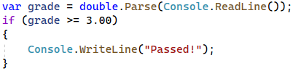

Passed or Failed
Modify the program from the previous problem, so it will print "Failed!", if the grade is lower than 3.00.

Input
The input comes as a single double number.

Output
The output is either "Passed!" if the grade is more than 2.99, otherwise you should print "Failed!".

Examples
Input | Output |  | Input | Output
5.32 | Passed! |  | 2.36 | Failed!

Solution
We start by reading a floating-point number from the console. Next, we print in the else statement the appropriate message.
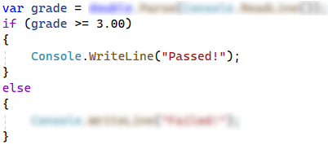

Back in 30 Minutes
Every time John tries to pay the bills he sees on the cash desk the sign: "I will be back in 30 minutes". One day John was tired of waiting and decided he needed a program, which prints the time after 30 minutes, so he could come back after exactly 30 minutes. He is not able to write the program by himself, so he asks for help.

Input
Two numbers are read from the console:
- The first number is hours and will be between 0 and 23.
- The second number is minutes and will be between 0 and 59.

Output
Print on the console the time after 30 minutes. The result should be in format hh:mm. The hours may contain one or two numbers and the minutes always have two numbers (with leading zero).

Examples
Input | Output |  | Input | Output |  | Input | Output |  | Input | Output |  | Input | Output
1  46 | 2:16 |  | 0  01 | 0:31 |  | 23  59 | 0:29 |  | 11  08 | 11:38 |  | 11  32 | 12:02

Hints
- Add 30 minutes to the initial minutes, which you receive from the console. If the minutes are more than 59, increase the hours by 1 and decrease the minutes by 60. In the same way, check if the hours are more than 23. When you print check for leading zero.

Month Printer
Create a program that receives an integer and prints the matching month. If the number is more than 12 or less than 1, print "Error!".

Input
You will receive a single integer on a single line.

Output
If the number is within the boundaries, print the corresponding month, otherwise print "Error!".

Examples
Input | Output |  | Input | Output
2 | February |  | 13 | Error!

Solution
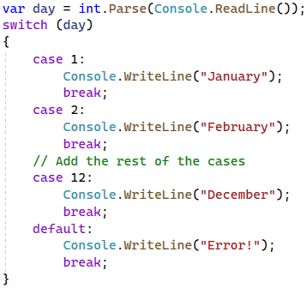

Foreign Languages
Create a program that prints the spoken language in a country. You will receive only the following combinations:
- English is spoken in England and the USA.
- Spanish is spoken in Spain, Argentina, and Mexico.
- For the others, we should print "unknown".

Input
You will receive a single line of input, representing the country name.

Output
Print the language that is spoken in the given country. In case the country is unknown for the program, print "unknown".

Examples
Input | Output |  | Input | Output
USA | English |  | Germany | unknown

Hint
Think about how you can merge multiple cases, to avoid writing more code than you need to.

Theatre Promotions
A theatre sails tickets at discount and a program is needed to calculate the price of a single ticket. If the given age does not fit one of the categories, you should print "Error!".
The prices of the tickets are as follows:
Day / Age | 0 <= age <= 18 | 18 < age <= 64 | 64 < age <= 122
Weekday | 12$ | 18$ | 12$
Weekend | 15$ | 20$ | 15$
Holiday | 5$ | 12$ | 10$

Input
The input comes in two lines. On the first line you will receive the type of day. On the second – the age of the person.

Output
Print the price of the ticket according to the table or "Error!", if the age is not in the table.

Constraints
- The age will be in the interval [-1000…1000].
- The type of day will always be valid.

Examples
Input | Output |  | Input | Output |  | Input | Output |  | Input | Output
Weekday  42 | 18$ |  | Holiday  -12 | Error! |  | Holiday  15 | 5$ |  | Weekend  122 | 15$

Solution

Step 1. Read the Input
We need to read two lines. The first one will be the type of day. We will convert it to lower case letters with the method "ToLower()". After that, we will read the age of the person and declare a variable – price, which we will use to set the price of the ticket.
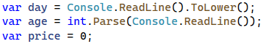

Step 2. Add If-else Statements for the Different Types of Day
For every type of day, we will need to add different cases to check the age of the person and set the price. Some of the age groups have equal prices for the same type of day. This means we can use logical operators to merge some of the conditions.
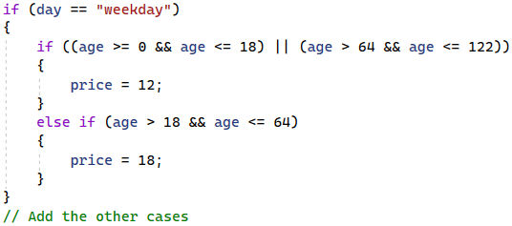
Think where and how you can use logical operators for the other cases.

Step 3. Print the Result
We can check if the price has a value different than the initial one. If It does, that means we got a valid combination of day and age, and the price of the ticket is saved in the price variable. If the price has a value of 0, then none of the cases got hit, therefore we have to print the error message.
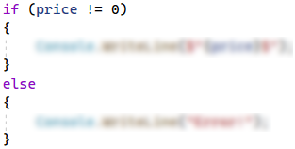

Divisible by 3
Create a program, which prints all the numbers from 1 to 100, that are divisible by 3. You have to use a single for loop. The program should not receive input.

Solution
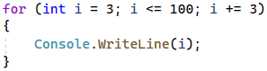

Sum of Odd Numbers
Create a program that prints on a new line the next n odd numbers (starting from 1). On the last row print the sum of all n odd numbers.

Input
A single number n is read from the console, indicating how many odd numbers need to be printed.

Output
Print the next n odd numbers, starting from 1, separated by new lines. On the last line, print the sum of these numbers.

Constraints
- n will be in the interval [1…100]

Examples
Input | Output |  | Input | Output
5 | 1  3  5  7  9  Sum: 25 |  | 3 | 1  3  5  Sum: 9

Solution
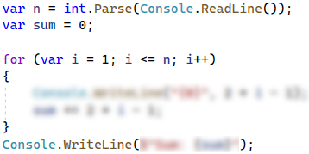

Multiplication Table
Create a program that receives an integer as an input. Print the 10 times table for this integer. See the examples below for more information.

Output
Print every row of the table in the following format:
{theInteger} X {times} = {product}

Constraints
- The integer will be in the interval [1…100]

Examples
Input | Output |  | Input | Output
5 | 5 X 1 = 5  5 X 2 = 10  5 X 3 = 15  5 X 4 = 20  5 X 5 = 25  5 X 6 = 30  5 X 7 = 35  5 X 8 = 40  5 X 9 = 45  5 X 10 = 50 |  | 2 | 2 X 1 = 2  2 X 2 = 4  2 X 3 = 6  2 X 4 = 8  2 X 5 = 10  2 X 6 = 12  2 X 7 = 14  2 X 8 = 16  2 X 9 = 18  2 X 10 = 20

Multiplication Table 2.0
Rewrite the program from the previous task so it can receive the multiplier from the console. Print the table with the multiplier in the interval from the given number to 10. If the given multiplier is more than 10, print only one row with the integer, the given multiplier, and the product. See the examples below for more information.

Output
Print every row of the table in the following format:
{theInteger} X {times} = {product}

Constraints
- The integer will be in the interval [1…100]

Examples
Input | Output |  | Input | Output |  | Input | Output
5  1 | 5 X 1 = 5  5 X 2 = 10  5 X 3 = 15  5 X 4 = 20  5 X 5 = 25  5 X 6 = 30  5 X 7 = 35  5 X 8 = 40  5 X 9 = 45  5 X 10 = 50 |  | 2  5 | 2 X 5 = 10  2 X 6 = 12  2 X 7 = 14  2 X 8 = 16  2 X 9 = 18  2 X 10 = 20 |  | 2  14 | 2 X 14 = 28

Even Number
Create a program that reads a sequence of numbers. If the number is even, print its absolute value in the following format: "The number is: {number}" and terminate the program. If the number is odd, print "Please write an even number." and continue reading numbers.

Examples
Input | Output |  | Input | Output
1  3  6 | Please write an even number.  Please write an even number.  The number is: 6 |  | -6 | The number is: 6

Debug the Code: Holidays Between Two Dates
You are assigned to find and fix all bugs in the existing code. By using the Visual Studio debugger, place a breakpoint and find the lines of code that produce incorrect or unexpected results.
You are given a program (existing source code) that aims to count the non-working days between two dates in format day.month.year (e.g. between 1.05.2015 and 15.05.2015 there are 5 non-working days – Saturday and Sunday).

Examples
Input | Output | Comments
1.05.2016  15.05.2016 | 5 | There are 5 non-working days (Saturday / Sunday) in this period:  1-May-2016, 7-May-2016, 8-May-2016, 14-May-2016, 15-May-2016
1.5.2016  2.5.2016 | 1 | Only 1 non-working day in the specified period: 1.05.2016 (Sunday)
15.5.2020  10.5.2020 | 0 | The second date is before the first. No dates in the range.
22.2.2020  1.3.2020 | 4 | Two Saturdays and Sundays:  - 22.02.2020 and 23.02.2020  - 29.02.2020 and 1.03.2020
You can find the broken code in the judge system: Broken Code for Refactoring. It looks as follows:
HolidaysBetweenTwoDates.cs
using System;
using System.Globalization;

class HolidaysBetweenTwoDates
{
static void Main()
{
var startDate = DateTime.ParseExact(Console.ReadLine(),
"dd.m.yyyy", CultureInfo.InvariantCulture);
var endDate = DateTime.ParseExact(Console.ReadLine(),
"dd.m.yyyy", CultureInfo.InvariantCulture);
var holidaysCount = 0;
for (var date = startDate; date <= endDate; date.AddDays(1))
if (date.DayOfWeek == DayOfWeek.Saturday &&
date.DayOfWeek == DayOfWeek.Sunday) holidaysCount++;
Console.WriteLine(holidaysCount);
}
}

Hints
There are 4 mistakes in the code. You've got to use the debugger to find them and fix them. After you do that, submit your fixed code in the judge contest.

